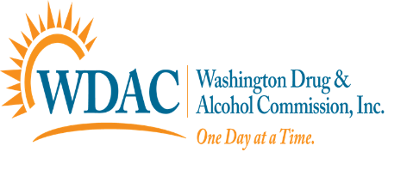
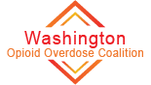

Project Refuge Training Event
The Washington County Opioid Overdose Coalition would like to invite all faith based leaders and pastors to attend our next Project Refuge training. At this training you will learn:
- about the disease of addiction and how it affects families
- what to do when you encounter someone who needs help
- how to administer Naloxone/Narcan
- hear about the efforts happening here in Washington County to address the opiate epidemic

All attendees will receive the necessary resources to be part of this outreach ministry called Project Refuge.

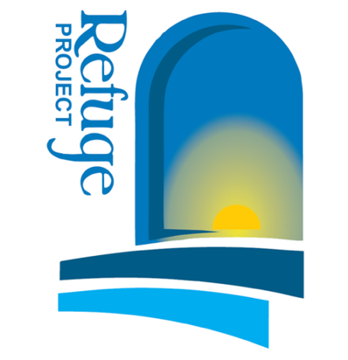
Date: May 3, 2019
Time: 8:00am-1:00pm
Location: First Presbyterian Church of Monongahela
609 Chess Street, Monongahela, PA 15063
Pre-Registration is Encouraged

Complementary continental breakfast and lunch

Please R.S.V.P to Rebecca Cumpston at 724-223-1181 x143 or email Rebeccac@wdacinc.org

