PROCEDURE
The underlying principle of any forensic investigation is that it is an inferential process. It involves the integration of multiple sources of information along with basic concepts of Forensic Epidemiology, in order to arrive at a conclusion surrounding the agents involved in an individual overdose. When interpreting the results of a toxicology report, the initial step is the separation of the specific drugs from their metabolites, no matter whether metabolites are active or inactive.
Identification of other therapeutic agents (antibiotics, over the counter drugs, etc.) and those illicit drugs such a marijuana that are not thought to result in death can then be retained in the database but labelled as non-contributory.
The Position Paper published by the NAME in 2014, directed specifically towards the issue of opioid deaths interpretation of opioids, is the best guide to the general analysis of scene investigation, specimen selection, history taking and final death certification [2].
- Initial steps for each overdose death case

  - Review toxicology report to identify parent drugs and metabolites, using the form and drug reference tools available on the OverdoseFreePA (ODFPA) website. Only parent drugs will be considered to have contributed to the death, even in the case of active metabolites. Metabolites will be retained in this database for possible later use.

  - Identify agents listed on some reports that are present because of consumption of drugs or substances that are either legal or not thought to be toxic.
    - Examples:
      - Caffeine
      - Nicotine/cotinine
      - Theobromine (tea)
      - Cannabinoids (Marijuana)

  - Identify specimen source
    - Blood – preferred source
      - Hospital admission blood (depending on location of death)
      - Central (heart) vs. peripheral (femoral) and/or sub-clavian.
    - Other substrates – urine, vitreous fluid, bile
      - In cases where there is decomposition, consider liver as a source for toxicology screening.

  - Review findings from the scene
    - Drug paraphernalia
    - Prescription bottles
    - Evidence of injection sites
    - Overlapping prescriptions
    - Presence of Naloxone
    - (NOTE: See Table 1. – NAME Standard)

Interpretation of results of Toxicology Report

GENERAL NOTE: With a relatively small amount of practice, once the issue of parent vs. metabolite drugs has been resolved, all but a few of the agents encountered on the toxicology report can be recognized as either active drugs or non-contributory to the death.
The actual measured level of the specific drug is often not the critical factor in this evaluation. There are several tables and listings of drugs and agents dividing these measured levels into “Therapeutic”, “Toxic” and “Lethal” levels [3-8]This analysis, except for the “Lethal “category, is typically established in living individuals and sometimes from clinical trials.
This protocol follows the reasoning that all agents thought to have toxic effects should be considered as “contributory” to the specific death, without making the attempt to separate the relative contributions of individual drugs or eliminate some agents because of, for example, low measured levels. This will result constructing the broadest possible dataset possible and allow for the future research into unresolved areas. The relatively few instances that present difficulties in interpretation, thus leaving the final decision up to the certifying authority.

Two situations arise that result in significant discrepancies between reporting counties in the Commonwealth of Pennsylvania as well as between different jurisdictions in the United States.

First, documentation of paraphernalia and/or drug history may not be available forms jurisdiction lacking infrastructure to perform and report a complete scene investigation. If scene information is lacking, there are two possible options available to the individual vetting the report.
- Choose morphine as the drug resulting in death because it is the present in the report and heroin is absent, or
- Opine that the drug that was ingested was, in fact, heroin and that morphine is present as “the last man standing:” after metabolism.
It is known from the NFLIS data that the incidence of morphine being in seized evidence (NFLIS) nationwide is less than 2%. In the Crime Lab of Allegheny County that incidence is 0.2%. Jurisdictions lacking the resources to develop anecdotal evidence that the drug consumed was heroin, such as complete scene investigation, may opt to list morphine as the drug causing the death.
The second recurrent issue is resolving the parent/metabolite relationships in the benzodiazepines. The complexity here derives from the situation where metabolites of one therapeutic agent results in other agents that may be marketed as primary drugs. Valium (diazepam) is perhaps the most common therapeutic agents manifesting this phenomenon (SI 4).

- Opioids
  - Include the following opioids if listed on an individual toxicology report:
    - Fentanyl
    - Fentanyl Related Substances, NPSO
      - U-47700
      - Uranyl fentanyl
      - Carfentanil
      - Acetyl fentanyl
      - 4-ANPP
    - Prescription opioids: Divided into opioids with active/inactive metabolites that are not pharmaceutical preparations, and opioids that have active metabolites that are identical to pharmaceutical preparations.
      - Drugs with active/inactive metabolites that are unique, resulting in a simple parent/child relationship
- Buprenorphine: Norbuprenorphine
- Dihydrocodeine: Nordihydrocodeine
- Fentanyl: Norfentanyl,Despropionylfentanyl, Hydroxyfentanyl
- Hydromorphone: Hydromorphone -3 -glucuronide, Hydromorphic
- Methadone: EDDP, EDMP, Methadol
- Meperidine: Normeperidine
- Oxymorphone: oxymorphone-3-glucaronide, 6- oxymorphol
- Propoxyphene: Norpropoxyphene
- Tramadol: N-desmethyltramamdol, O-desmethyltramadol

      - Opioids with active metabolites marketed as individual agents (SI 3)
- Codeine - metabolized into morphine and norcodeine
  - Morphine is a pharmaceutical drug.
  - Norcodeine inactive, not pharmaceutical drug.
  - In blood, the codeine to morphine ratio exceeds 1 following acute dose.
  - In urine codeine, norcodeine and morphine may be present.
  - Hydrocodone may be present in urine as a minor metabolite (trace amounts).

- Hydrocodone - metabolized into hydromorphone, norhydrocodone, and dihydrocodeine (SI 2).
  - Hydromorphone and dihydrocodeine are pharmaceutical drugs.
  - Hydrocodone is primary analyte in blood, low levels of metabolites may be present.
  - In urine, hydrocodone, norhydrocodone, hydromorphone, and dihydrocodeine may be present (Milone, 2012).

- Morphine - metabolized to normorphine, morphine-3-glucaronide (3-G), morphine-6-glucaronide (6-G) (SI 2)
  - Morphine, morphine-6-G, morphine-3-G present in blood
  - Morphine-6 -G is an active metabolite
  - Hydromorphone may present as a minor metabolite in urine, in trace amounts [9]
- Oxycodone - metabolized into oxymorphone and noroxycodone.
  - Oxymorphone is a pharmaceutical drug.
  - Noroxycodone active, but not pharmaceutical agent
  - Oxycodone is primary analyte in blood, followed by noroxycodone and oxymorphone
  - Oxymorphone levels in blood are typically low, but dependent on the enzyme genotype. Some individuals are poor metabolizers of oxycodone, and others are ultra rapid metabolizers leading difficulty in identifying the parent drug or drugs. These cases should be submitted for further review.

- Heroin - metabolized into 6-monoacetylmorphine (6-MAM) and morphine (SI 2).
  - 6-MAM, also known as 6-acetylmorphine is a metabolite unique to heroin.
  - Morphine is the primary analyte in blood.
  - 6-MAM present in blood or urine depending on many different factors, including dose, route of administration and survival time.
  - Codeine is an impurity in heroin and may be present in trace amounts in urine [10].

  - Challenging Classifications - Morphine could be present as a result of morphine administration, or as a metabolite of codeine or heroin.

The following guidelines will enable the reviewer to identify the parent drug in most instances:

    - If the principle metabolite of heroin, 6-monoacetylmorphine (6-MAM), is found in any of the submitted fluids, then the parent is heroin [9]
    - If morphine alone is found in any of the submitted fluids, then it MOST LIKELY originated from heroin. Factors that increase this likelihood include:
      - Scene evidence of paraphernalia, stamp bags, tourniquets, syringes, etc.;
      - Stated history of prior opioid abuse;
      - Presence of fentanyl in the same case
        - It is increasingly rare to find either heroin (5.5%) or fentanyl (7.7%) as the only opioid present in an overdose death. In Allegheny County, this corresponds with stamp bag data. Presence of morphine in the urine with fentanyl in blood is most consistent with an origin of the morphine from heroin [11].
      - If low levels of codeine are present in the urine they are consistent with being an impurity of heroin
        - Higher levels of codeine and a codeine to morphine ratio of greater than 10:1 are most consistent with codeine as the parent drug, especially if supported by known prescription history and/or scene investigation [10].
      - If morphine is the only drug in the toxicology report, in the absence of 6-MAM, evidence should be sought for either morphine at the death scene.

- Benzodiazepine Class (NOTE: The class of benzodiazepines has complex pattern of metabolism, similar to opioids, with some common metabolites also marketed as therapeutic agents. The following analysis first identifies those agents without active metabolites and then provides a few simple rules to help identify problems with overlap of the agents (SI 4).
  - Drugs with no active metabolites
    - Lorazepam
    - Oxazepam
  - Drugs with active metabolite that are unique, resulting in a simple parent/child relationship
    - Alprazolam: α-Hydroxyalprazolam
    - Clonazepam: 7-Aminoclonazepam
    - Midazolam: α -Hydroxymidazoalm
    - Triazolam: α-Hydroxytriazolam
    - Flurazepam: N-1-Desalkylflurazepam, N-1-Hydroxyethyl-Flurazepam

  - Drugs with active metabolites marketed as individual agents
    - Diazepam - metabolized into nordiazepam, temazepam, and oxazepam
      - If nordiazepam is present, and low levels of temazepam and oxazepam, then diazepam is the parent
    - Chlordiazepoxide - metabolized into desmethylchlordiazepoxide, demoxepam, nordiazepam and oxazepam
      - If either desmethylchordiazepoxide or demoxepam are present, then chlordiazepoxide is the parent. If nordiazepam and oxazepam are also present, then classify as metabolites of chlordiazepoxide
    - Temazepam - metabolized into oxazepam
      - If temazepam and oxazepam are present, and no other benzodiazepines are detected, the parent drug is temazepam

  - Difficult classifications - presence of common metabolites without parent drug
    - Nordiazepam
      - If nordiazepam is present and diazepam is detected in any fluid, classify as metabolite of diazepam
      - Nordiazepam in the presence of chlordiazepoxide, demoxepam, or desmethylchordiazepoxide is classified as a metabolite of chlordiazepoxide
      - If only nordiazepam is present, review medical records and history for prescription information.
      - In rare instance, the parent drug may not be able to be identified. Nordiazepam is classified as the parent.
    - Oxazepam
      - If oxazepam is present and no other benzodiazepines, then oxazepam is the parent.
      - Oxazepam in the presence of diazepam is classified as the metabolite of diazepam.
      - Oxazepam in the presence of chlordiazepoxide, demoxepam, or desmethylchordiazepoxide is classified as metabolite of chlordiazepoxide.
      - Oxazepam in the presence of temazepam (and no other benzodiazepines) is classified as metabolite temazepam.

- Central Nervous System (CNS) Stimulants – consider all as contributors if present in apparent overdose deaths

  - Cocaine- metabolized into benzoylecgonine and ecgonine methyl ester.
    - Primary metabolite benzoylecgonine is frequently present in urine alone.
    - Other metabolites commonly detected include norcocaine and cocaethylene.
  - Amphetamines -
    - Amphetamine -no active metabolites.
    - Methamphetamine: metabolized the amphetamine.
    - 3,4- Methylenedioxyamphetamine (MDA) - no active metabolites.
    - 3,4-Methylenedioxymethamphetamine (MDMA, ecstasy) -
metabolized to MDAC.
    - Phentermine.
  - Bath salts – most commonly derived from or similar to cathinone, the active compound found in the plant kaht (Catha edulis).
    - MDPV (Methylenedioxypyrovalerone)
    - Methalone
    - mephadrone

- Selective Serotonin Release Inhibitors – (NOTE: These agents are marketed as anti-depressants and have a different mechanism of action than either the opioids or CNS stimulants and are most typically seen in high levels in suicidal deaths, but should still be considered as contributing if present.)
  - Citalopram (Celexa)
  - Escitalopram (Lexapro)
    - Citalopram/Escitalopram seen in some reports
  - Fluoxetine (Prozac)
  - Paroxetine (Paxil, Pexeva)
  - Sertraline (Zoloft)
  - Vilazodone (Viibryd)

CONCLUSION
This protocol is offered as procedure to be followed for the purposes of OverdosefreePA data analysis. It is created in the absence of any other known similar, publically available protocol. It is intentionally designed to be as inclusive as possible in identifying drugs or agents that are known to be toxic to humans and thus should be considered as contributory to the death. it is offered for scrutiny and future revision and should be considered a work in progress and as a first step towards improving death certification [12]

Supplemental Information

SI Figure 1: Cocaine

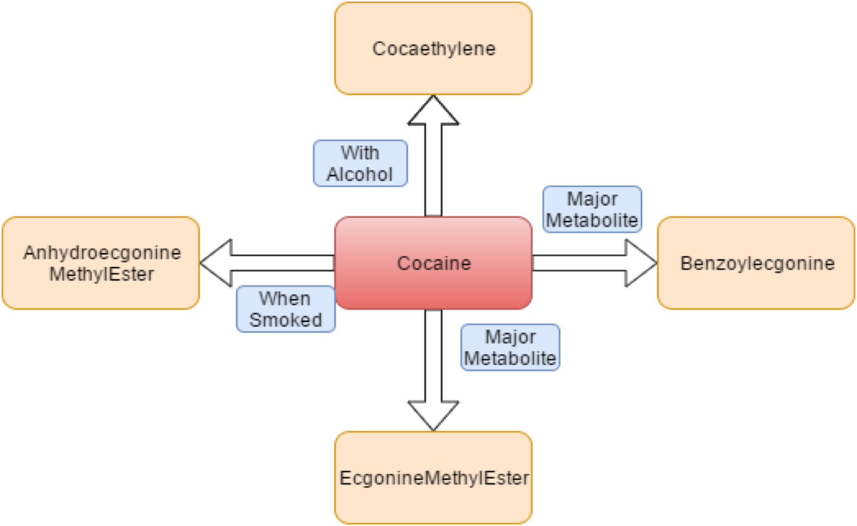
Metabolic pathway of cocaine in the body.

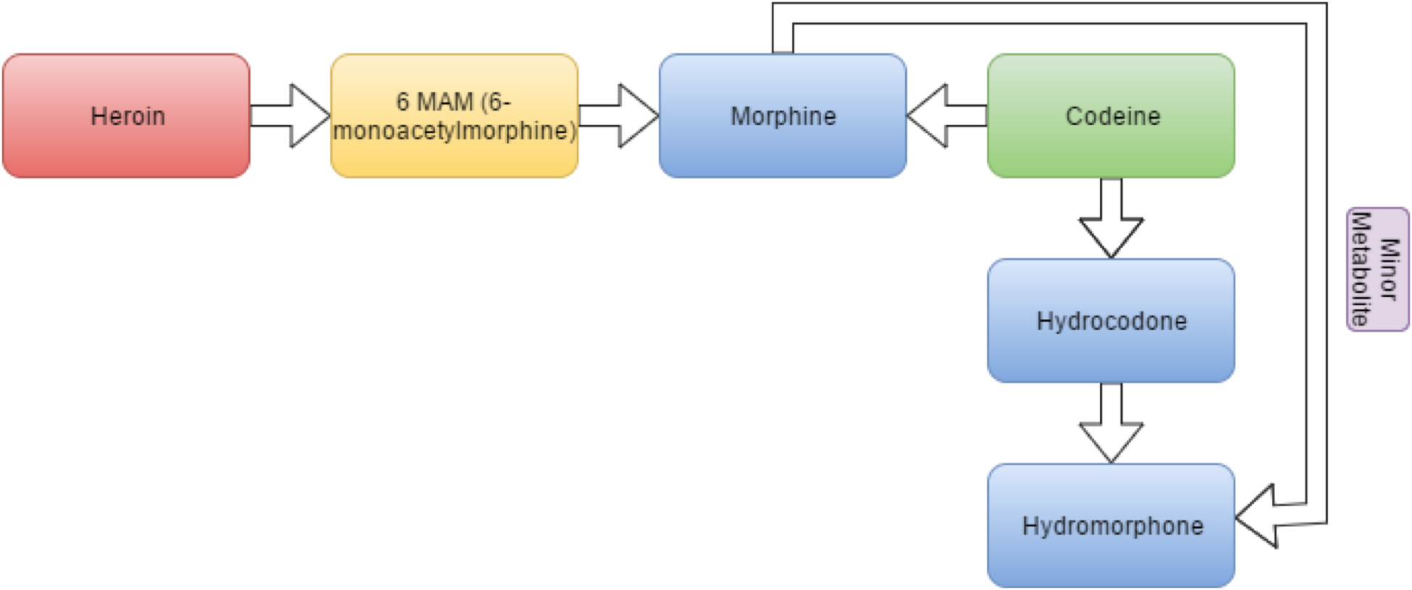
SI Figure 2: Opioids
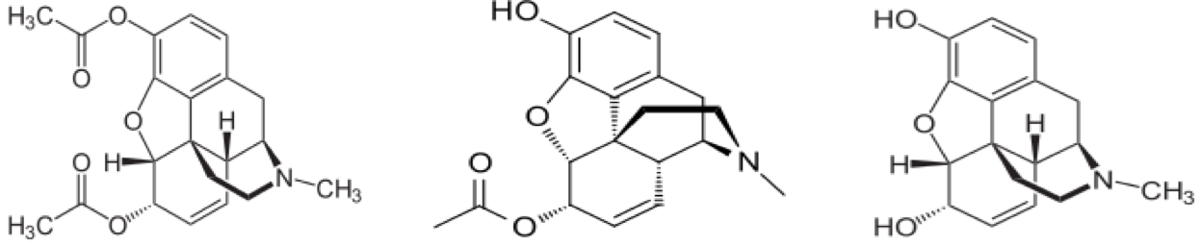
Synthetic/non-synthetic opioids metabolism in the body

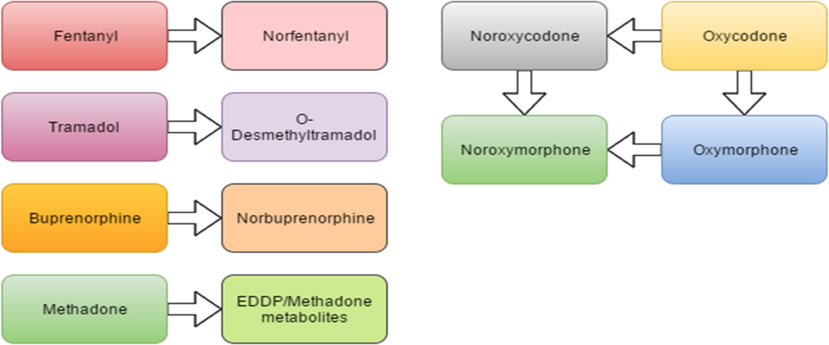
SI Figure 3: Synthetic Opioids

Metabolic pathway of synthetic opioids in the body.

SI Figure 4: Benzodiazepines

Metabolic pathway of benzodiazepines in the body.

Works Cited
1. Edwards, H.T., Strenghening Forensic Science in the United States: A Path Forward. 2009, National Academy of Sciences.
2. Davis, G.G., Complete republication: National Association of Medical Examiners position paper: Recommendations for the investigation, diagnosis, and certification of deaths related to opioid drugs. J Med Toxicol, 2014. 10(1): p. 100-6.
3. Drummer, O.H., Postmortem toxicology of drugs of abuse. Forensic Sci Int, 2004. 142(2-3): p. 101-13.
4. Lehrmann, E., et al., Postmortem diagnosis and toxicological validation of illicit substance use. Addict Biol, 2008. 13(1): p. 105-17.
5. Reis, M., et al., Reference concentrations of antidepressants. A compilation of postmortem and therapeutic levels. J Anal Toxicol, 2007. 31(5): p. 254-64.
6. Launiainen, T. and I. Ojanpera, Drug concentrations in post-mortem femoral blood compared with therapeutic concentrations in plasma. Drug Test Anal, 2014. 6(4): p. 308-16.
7. Regenthal, R., et al., Drug levels: therapeutic and toxic serum/plasma concentrations of common drugs. J Clin Monit Comput, 1999. 15(7-8): p. 529-44.
8. Martin Schulz, S.I.-B., Hilke Andresen, Therapeutic and toxic blood concentrations of nearly 1,000 drugs and other xenobiotics. Critical Care, 2012. 16(4).
9. Ellis, A.D., et al., Identifying cases of heroin toxicity where 6-acetylmorphine (6-AM) is not detected by toxicological analyses. Forensic Sci Med Pathol, 2016. 12(3): p. 243-7.
10. Harruff, R.C., Tracking the Opioid Drug Overdose Epidemic in King County, Washington Using and Improved Methadoogy for Certifying Heroin Related Deaths. Academic Forensic Pathology, 2015: p. 499-506.
11. Mertz, K.J., J.K. Janssen, and K.E. Williams, Underrepresentation of heroin involvement in unintentional drug overdose deaths in Allegheny County, PA. J Forensic Sci, 2014. 59(6): p. 1583-5.
12. Jennifer Sable, P., Recommendations and Lessons Learned for Improved Reporting of Drug Overdose Deaths on Death Certificates 2016, Council of State and Territorial Epidemiologists. p. 1-16.

Designer Opioids http://www.nmslabs.com/tests/Designer-Opioids--2017-Scope---Blood/1480B

